**Static Overload Indexes**

**Requirements:**

* To check whether the operational limit of the transmission lines has been breached.
* To check whether steady state is reached.

**Proposed Method:**

* Operational Limit Check:
* For the overload we will use the maximum value of each line to compare to a mean value at the end of the simulation.
* A global overload index will be computed, in similar way than before (see fx in deliverable), the difference here will be that the Smax,i will be taken from the platform directly.
* To provide more detailed information about which lines have breached limits, we will compute, and save in a matrix and provide them as output.
* Steady state check:
* We will determine if a simulated output of the line active power is reaching stability by comparing mean of slope computed from time windows.
* The computation will give similar results (less than or equal to 1, bigger than 1 and much bigger than 1) as an output, where less than or equal 1 is steady state, and much bigger than one is not steady state.
* The computation approach above, will be carried out for each line, and stored in an individual line index gi.

**Overload Index-Theory:**

$$f_x=\sum_{i=1}^{N_{l}}{wf_{i}{\left(\frac{S_{mean,i}}{S_{max,i}}\right)}^{P}}$$

Where f_x is the overload performance index for the operating point x, Nl is the number of transmission lines, $S_{mean,i}$ and $S_{max,i}$ are the average and maximum power flows of the i*th* line, respectively, $wf_{i}$ is a weighting factor for each transmission line, which can be defined by the best judgment of the system operator, for instance $wf$ = [1, 1, ..., 1] for unitary weight in all the lines. Finally p is an exponent to reduce masking effects, which means that a high value of the exponent will scale the effects of an overload resulting in a higher index value. The final value of the over load index f_x is a scalar, and its interpretation is as follows:

$f_{x}=1-→$ All lines are within the limits

$f_{x}>1-→$ At least one line has violated its limit

$f_{x}≫1-→$ A severe violation has occurred

The state (steady state/not steady state) of the power flow in the lines is assessed based up on the difference in slope change of power flow in the lines at the end of simulation. Three interval each of size 10 seconds are considered in the given data from the end time of simulation. The average slope of each interval is calculated (S1, S2, S3). The difference in slope between first two intervals and last two intervals is calculated. If the difference is less/zero implies that the power flow variation in that particular line is reduced. The following figure depicts the above explanation.

The final outputs of the overload index calculation are the following,

* f_x is the final overload index of the given system.
* ‘F’ is a matrix, which gives the Level of loading of each line as per the index calculation. F=[F1 F2 F3….Fn] where if Fn >>1 indicates that the operational limit is violated.
* ‘f’ is a matrix, which gives the list of lines that violated operational limit.
* ‘G’ is a matrix, which gives the state of the given lines. G=[G1 G2 G3….Gn] where if Gn >>1 indicates that the lines has not reached steady state.
* ‘g’ is a matrix, which gives list of the lines that are yet to reach steady state.

**Simulation Results:**

The main execution file for voltage stability indexes is ‘static_overload _index_testing‘. The execution of this file is explained below with ‘Over_Load’ data file. The Matlab function ‘static_overload’ calculates the indexes and identifies the overloaded lines in the given data file.

* The state (steady state/not steady state) of the power flow in the lines is assessed based up on the difference in slope change of power flow in the lines at the end of simulation. Three intervals each of size 10 seconds are considered in the given data from the end time of simulation.
* The average slope of each interval is calculated (S1, S2, S3).
* The difference in slope between first two intervals and last two intervals is calculated.
* If the difference is less/zero implies that the power flow variation in that particular line is reduced.

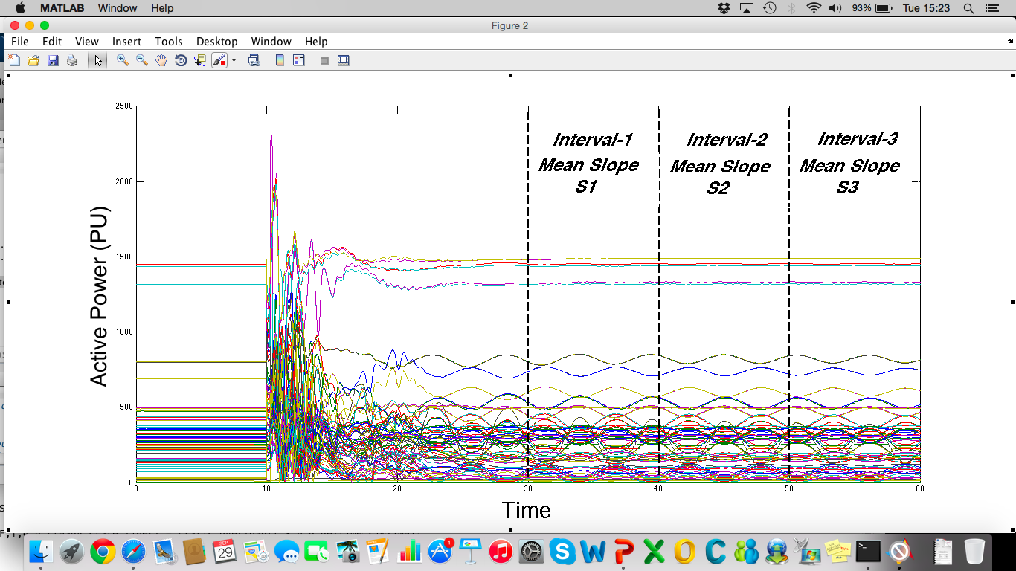

Figure-1